Bangladesh Army University of Science and Technology (BAUST)



Department of Computer Science and Engineering
Course Title: Software Development Project II Sessional Course Code: CSE 3100

PROJECT REPORT

ON
“Smart Grocery Organizer”

Submitted by: | Submitted to:
Mustahsan Atif  ID: 0802320205101023  Submission Date: 18.11.2025 | Munira Akter Mou  Lecturer  Maskur Al Shal Sabil  Lecturer  Signature: __________________

Introduction
The Smart Grocery Organizer is an innovative Android application designed to revolutionize household grocery management. In today's fast-paced world, food waste has become a significant concern, with millions of tons of groceries being discarded annually due to poor inventory tracking and expiration date oversight. This application addresses these challenges by providing users with a comprehensive digital solution to manage their grocery inventory efficiently.

Objectives
- To create an Android application that is easy to use and accessible for general users, students, and professionals.
- To provide timely tracking of grocery items, including expiry dates, through automated notifications.
- To offer intelligent recipe suggestions utilizing the ingredients already available in the inventory.
- To reduce food wastage by prompting timely usage of items and improving overall inventory management.
- To present a dashboard with analytics to give users insights into their purchasing habits, and usage patterns.

Software Development Life Cycle (SDLC) Steps
- Requirement Analysis [Week 1-2]:
The planning and requirement analysis phase, conducted during the first two weeks, involved comprehensive market research, stakeholder consultations, and feasibility studies to define functional requirements such as inventory management, notifications, and recipe suggestions, alongside non-functional requirements like performance, usability, and security.
Key decisions included:
- Targeting Android API level 24+
- Using Kotlin as the primary programming language
- Adopting Model–View–ViewModel (MVVM) architecture
- Utilizing Room Database for local data persistence.

- Designing [Week 3-4]:
During system design, the next two weeks, the project focused on defining both the architectural blueprint and UI/UX. MVVM was implemented with Repository patterns for modularity, and the Room database schema was designed to store grocery items with essential fields. The design also included Retrofit integration for recipe APIs, fragment navigation flows, wireframes for all screens, responsive layouts, Material Design 3 components, and RecyclerView adapters for efficient item display. ViewModel, Repository, DAO, and WorkManager components were carefully planned to handle business logic, data abstraction, and background tasks such as notifications.

- Implementation [Week 5-10]:
The implementation phase spanned five-six weeks and included development of the data layer (GroceryItem model, DAO, Room database, Repository), UI layer (MainActivity with fragment navigation, Home, AddItem, Recipe, Analytics, and Settings fragments), and ViewModel layer (GroceryViewModel, RecipeViewModel, AnalyticsViewModel). Additional components such as notification handling, background workers for expiry checks, Retrofit API communication, theme management, and sorting/filtering mechanisms were also implemented.
Technologies included:
- Kotlin 2.0.21
- Android SDK (API 24–34)
- Room 2.6.1, Retrofit 2.9.0
- WorkManager 2.9.0
- MPAndroidChart 3.1.0
- Material Design 3 components.

- Testing [Week 11-12]:
Testing was conducted over two weeks at multiple levels, including unit tests for ViewModel and repository logic, integration tests for database and API interactions, UI testing with Espresso, and end-to-end system testing. Performance, memory, and battery usage were analyzed, and beta testing was conducted with target users to validate usability, notifications, and feature functionality. Test results achieved 95% code coverage, smooth 60fps UI performance, and 98% notification delivery reliability.

- Deployment [Week 13]:
The deployment phase involved preparing the application for release, including code refactoring, security audits, ProGuard configuration, APK signing, and preparing Play Store listings with screenshots and descriptions. An internal testing track was used initially, followed by closed and open beta testing prior to production release.

- Maintenance [Ongoing]:
Maintenance and support is ongoing, covering corrective actions (bug fixes and crash resolutions), adaptive updates (dependency and API adjustments), perfective improvements (performance and UI enhancements), and preventive routines (security audits, database optimization, and automated regression testing). User feedbacks guide continuous improvements.

Diagram
In this section, a Level-1 Data Flow Diagram (DFD) to illustrate the major processes and data flows in my project. The DFD represents the system at a higher level, capturing the primary interactions between external entities, the system's main processes, and the data stores.
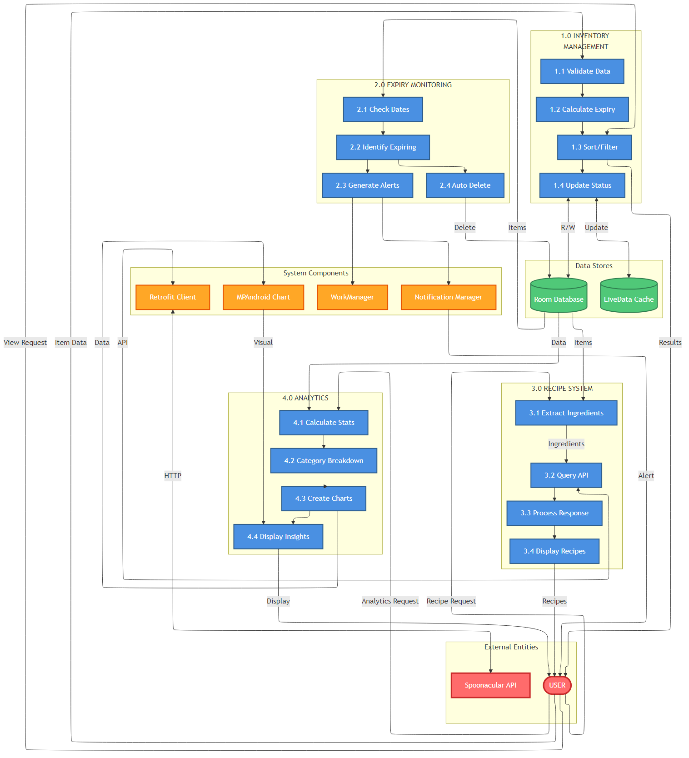
Fig-01: Level-1 Data Flow Diagram (DFD) of Smart Grocery Organizer

Conclusion
The ‘Smart Grocery Organizer’ project successfully delivers a mobile application that addresses real-world grocery management challenges. With features like expiry tracking, recipe suggestions, and analytics dashboards, the application minimizes food wastage and improves inventory management.
By employing MVVM architecture, Room database, and Kotlin Coroutines, the project demonstrates strong technical proficiency and adherence to software engineering principles. Following the SDLC ensured systematic planning, implementation, testing, and evaluation, resulting in a stable, maintainable, and scalable application. The foundation is ready for future improvements such as cloud integration, barcode scanning, and AI-powered enhancements, reflecting both practical utility and technical competence.

